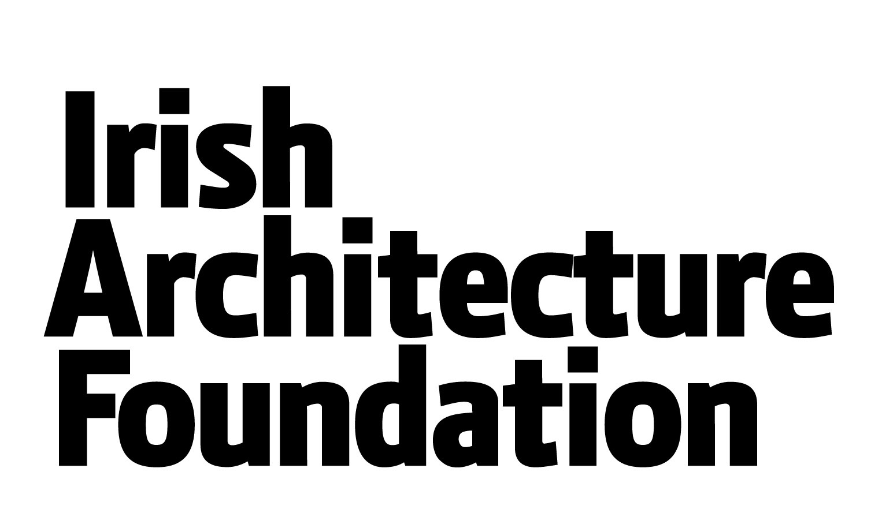

Information for Architects/Architecture Graduates

About the Irish Architecture Foundation
Established in 2005, the IAF is an independent organisation dedicated to the promotion of architecture as culture. We encourage people to engage with their built environment, to inspire new ways of thinking about architecture and the National Architects in Schools Initiative (NASI) delivers this core aim.

About the National Architects in Schools Initiative
The National Architects in Schools Initiative provides transition Year students, in 30 schools nationwide, with first-hand experience of the design process under the guidance of an architect or architectural graduate. Architects and teachers are trained to work collaboratively to deliver student workshops over a 12 hour period of class contact time. The initiative is supported by on-line resources and an IAF publication for students, teachers and architects called My Architecture Design Journal. (www.mydesignjournal.ie)

The National Architects in Schools Initiative is devised and delivered by the IAF and co-funded by the Arts Council, the Department of Education and Skills, the Department of Arts, Heritage, Regional, Rural and Gaeltacht Affairs under the Government Policy on Architecture implementation programme 2013.

The National Network of Education Centres (ECs), act as hubs for the programme in Cork, Donegal, Dublin (Drumchondra), Limerick, Waterford and Mayo allowing us to centralise training and resources for participating architects and teachers in each area.

Educational Outcomes
Students will experience architecture through hands-on design workshops and stimulus activities. The initiative is designed to compliment the aims of Transition Year and connects to many areas of the second-level schools syllabus, with rich opportunities for cross-curricular learning and development of specific skills and knowledge relating to design and architecture. Working closely with design professionals will enable students to gain an insight into working life and enhance awareness of career choices.

Participating students will:
- participate in the design process of architecture
- develop an appreciation of the importance of design and architecture
- use initiative, innovation and design thinking
- gain an insight to the professional life of an architect, and awareness of related careers
- learn about building for a sustainable future and about their architectural heritage.
- gain skills in debating, problem solving, teamwork and presentation by communicating with their peers and adults
- gain new practical skills and build on existing abilities (eg. sketching, technical drawing, model-making, writing and photography.)
The scheme is complimentary to many Senior Cycle subjects, including Art, Maths, Sciences, Design and Communication Graphics, Construction Studies, Home Economics, English, History & Geography. The Project-Based Learning approach of the scheme supports individual research and classroom based activities, providing diverse learning opportunities and curricular links. The initiative also provides specific enhancement of numeracy and literacy, design thinking and innovation.
Role of Architect
- Architects will commit to a maximum of 20 hours of work, split roughly into 8 hours of planning time and 12 hours of classroom / workshop time.
- Architects will collaborate with nominated teachers on the planning and delivery of workshops.
- Architects will deliver a series of workshops/classes that engage students in the architecture design process and enhance student awareness of architecture.
- Architects will attend planning and training meetings as outlined in “Support and Training”
- Architects will maintain communications with the IAF and Education Centres as required.
- Architects will submit project content (summary of projects) and Evaluation Survey (template to be provided) prior to drawing down payment.

Criteria for participating Architects/Architecture Graduates
Architectural qualifications: Graduate of accredited School of Architecture or professional registration as an Architect.

Communication skills: Experience of public/youth engagement in architecture is desirable. Other areas of experience of public engagement are also considered relevant (eg. teaching, talks, tours, community collaboration, volunteering, other communication/customer service).

Recruitment process for Architects
IAF’s Recruitment procedure for Architects include: application form, CV, interview in person or via skype if necessary and Architects will be subject to Garda vetting as part of the recruitment process.
All applications are made directly to the IAF and shortlisted candidates will meet the Education Curator Rebecca Blake for interview and further information.

Architects will be selected for assignment to schools based on application form, meetings and availability in terms of time and geographical range. The scheme is based on utilising local expertise and as such travel expenses are not included. Participants will then be assigned to schools to implement a project.

It is the IAF’s aim and hope that the National Architects in Schools Initiative will expand in the future, both in numbers of schools and geographical spread, providing more opportunities for architects and graduates. The IAF is increasingly contacted by schools and organisations wishing to participate in architecture based education projects and uses all available funding opportunities to establish diverse schools projects.

Payment
Maximum 20 hours @ €50 per hour including all taxes and expenses.
Allocated time is c. 12 hours class contact time and up to 8 hours for preparation and planning.
Payment to be drawn down on completion of project and evaluation report, via invoice to IAF.

School support
Participating schools* have committed to providing the following support:
1Teacher involvement: A nominated teacher will collaborate with the architect during advance planning sessions and during class workshops. The scheme is designed to foster teacher architect collaboration where peer-to-peer learning and training happens within that exchange. The cross-curricular nature of the project presents an opportunity for teachers from other subjects to participate and/or contribute valuable perspectives.
2) Allocation of time: The school will accommodate the programme within the school timetable for a minimum of 12 hours of classroom workshop time with the architect plus additional class time for students to continue project work. Timetabling is the responsibility of the school and architect working together. There is no required format for the project although IAF research to date, suggests that a six to ten week period is effective, run as a weekly “double-period” workshop.
3) Resources: Schools have committed to the allocation of materials for the project at a cost of c. €150 - €200. Architects and teachers will collaborate on identifying and sourcing appropriate materials.
4) Allocation of space: The school will provide appropriate working and storage space during the project and a temporary display of student work on completion.

*Schools in the five EC catchment areas were invited to apply to the scheme in May. The application process for schools participation is almost complete for 2017-18.

Project Theme
Architects will collaborate with teachers to devise a theme for the project. Diverse subjects and approaches are welcomed. The essential criteria for the workshops is that students experience the design process with an architect and acquire skills and knowledge relating to architecture by developing original design ideas which are relevant to their needs and interests. Projects which address locally specific themes are likely to successfully engage students as their inherent knowledge of their local built environment stimulates a sense of ownership of the project and provides a starting point for wider learning and skills acquisition.

Architects are welcome to use the IAF’s publication and school resource ‘My Architecture Design Journal’ as a basis for projects, but are equally welcome to develop different themes and approaches. A desired outcome of the two-year initiative is the creation of a suite of new project guidelines based on reports of projects undertaken in that period.

The overall approach, planning guidelines and supporting online resources contained in My Architecture Design Journal are likely to be useful regardless of theme, providing an adaptable template for the investigative and creative process of a design project with built in learning opportunities for specific skills such as scale drawing and model-making.

About My Architecture Design Journal
My Architecture Design Journal is a resource for schools from the IAF, supporting teacher-led or architect-led projects for 14-16 year-olds. The resource is centered on a bespoke Student Design Journal that guides students through a design project based on their school. Students record their investigative and creative work in the journal, following the step-by-step project guidelines. The resource also comprises a Teacher’s Handbook and is supported by online resources www.mydesignjournal.ie The blog will also feature postings by participants of architects-in-school projects.
Printed copies of the Student Design Journal and Teacher’s Handbook are available to teachers and architects interested in delivering architecture projects in schools. Please get in touch to request a copy from Rebecca Blake, IAF Education Curator education@architecturefoundation.ie

Support and Training
The IAF will offer training and support for all participating architects and teachers recruited to the programme. An national training session for all participating architects and teachers will take place in September to start the project and topics covered will include
- an overview of how the project works
- previous participating architects and teachers will share their past experiences
- a workshop to explore collaborative planning
- Architects will also receive training on and a copy of the IAF’s Child Protection Policy and sign agreement forms as required.
- Online resources:
www.architecturefoundation.ie
www.mydesignjournal.ie
- CPD: Architects may claim 20 structured CPD points for participation in the National Architects in Schools Initiative.

Timeline Overview

Application: Architects apply to the initiative by returning the application form to the IAF.

Deadline: Friday 4th August 2017, 5pm

Confirmation: The IAF will confirm pairings of schools and architects in September and make a national announcement of the participants of the National Architects in Schools Initiative 2017-18.
Date: September 2016

A national training day for architects and teachers will be held on Wednesday 27th September 2017. The training includes project planning guidelines, resources overview, collaborative training session and Q & A. Previous participating architects and teachers will share their experiences of delivering the programme.
Paired architects/teachers will organise their own follow-up meetings/phone calls to make specific arrangements and organise timetabling and materials.
Date: Wednesday 27th September 2017
Venue: TBC

Projects in schools will take place between October 2017 and May 2018.

National Exhibition: A National Exhibition of all students work on the project will take place on Wednesday 18th April 2018.

Enquiries: Contact Rebecca Blake, Education Curator, Irish Architecture Foundation // 01 874 7205 // education@architecturefoundation.ie

